

Queensland Integrity Commissioner

Encouraging confidence in public office & public institutions

ANNUAL REPORT 2019–2020



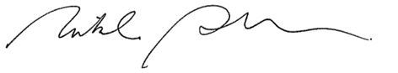The Honourable Curtis Pitt MP Speaker of the Legislative Assembly Parliament House
George Street
BRISBANE QLD 4000

Dear Mr Speaker

I am pleased to provide you with the Queensland Integrity Commissioner Annual Report 2019-2020. This is the third Annual Report since my appointment as Integrity Commissioner, and the eleventh report under the provisions of section 85 of the Integrity Act 2009. Previous Annual Reports were provided to the Premier as required by the provisions of the Public Sector Ethics Act 1994.

The Annual Report covers a further period of heightened demand in requests for the services of the Integrity Commissioner including requests for advice; requests in relation to the conduct of lobbyists; and invitations for education, training, and other sessions in line with the public awareness raising function of the Integrity Commissioner.

I am fortunate to enjoy the assistance and dedication of my staff who have supported me to fulfil my statutory obligations, and I wish to extend my gratitude to them. As well, I would like to congratulate those in public office and public institutions who have responded to the community’s desire for a heightened level of integrity and ethical awareness in the public sector.

I confirm the Annual Report complies with section 85 of the Integrity Act 2009. I also confirm the Annual Report is in general terms and does not contain information likely to identify advisees.

Yours sincerely

Dr Nikola Stepanov PhD (Melb.)

Queensland Integrity Commissioner

30 September 2020

Welcome
This Annual Report covers the 2019–2020 financial year, and draws to a close my third year as the Queensland Integrity Commissioner, and the final year of my first term of appointment. His Excellency, the Honourable Paul de Jersey AC, Governor of Queensland, acting by and with advice of the Executive Council, approved my reappointment for a further term of three years from 1 July 2020.
This financial year was the third year of significant heightened demand for advice on ethics and integrity issues, and also advice about the conduct of unregistered and registered lobbyists. We received 342 formal requests for advice, of which 307 were in relation to ethics and integrity advice, and 35 were regarding lobbing. I responded with 196 formal written advices on ethics and integrity matters, and 10 formal advices on lobbying matters. Remaining requests were appropriately dealt with in other ways to ensure the advisee’s need was not unmet, and I detail these actions later in this report.
The continued increase in demand for advice suggests that users value the unique advisory service our office provides and, in my view, is indicative of an ongoing commitment to ethics and integrity by those with public responsibilities.
As I have highlighted in previous years, sustaining a high quality and effective service, with a very small staff, in the face of extraordinary demand is the primary issue that I face on a day to day basis. As well, matters on which my advice are being sought are becoming increasingly more complex and less visible, and therefore consuming more

time and efforts. Indeed, it is not uncommon for there to be little general law or research on which to rely when setting the course of an advice on a matter. To that end, my staff and I undertake original research regularly and make our findings available publicly. To ensure robust standards are set, I also seek input widely from appropriate bodies such as the Crime and Corruption Commission and Crown Law, and I am grateful for their support.
I continue to be deeply committed to raising public awareness of ethics and integrity issues, including among public office holders and public servants. However, I acknowledge that the heightened demand for advice, and the fact that I am unable to delegate the formal advice function, limits my ability to conduct as many workshops and training sessions as I would prefer.
Certainly, I remain encouraged by the number of designated persons seeking advice on complex ethical and integrity issues, and I am very pleased about ongoing work and engagements with our collaborative partners, particularly the other members of the Integrity Committee, discussed later in this report.

Dr Nikola Stepanov
Queensland Integrity Commissioner

Contents
- About Us
- Strategic Plan 2019-2022
- Overview
7 2019–2020 Dashboard
8 Advice Function

11 Lobbyist Function
13 Public Awareness Function
- Operational & Compliance
- Staffing & Resources
- Financial Statement

Page 3

About Us
Message from the Director
In addition to functions under
Integrity Act 2009,
her
the the
Integrity Commissioner
must satisfy many of the statutory obligations of an office, including the provision of this report.
At the time of preparing this report, this office had three full-time staff assisting the Commissioner. All staff must therefore work together on major tasks. This presents both rewarding opportunities for staff involvement and additional challenges in meeting all statutory functions.
There was an increase during the year in the number of queries specifically related to lobbying. There are various exemptions under the lobbing provisions of the Integrity Act 2009 and limited case law to guide interpretation. In response, this office has published its views and interpretations in relation to common questions, and will continue to add to these over time. This office also completed an enhanced audit of lobbying activity during the financial year with the assistance of state and local government agencies.
Finally, a major change for the office during the year involved amendments to the Ministerial Code of Conduct. While the amendments inherently increase the Commissioner’s workload, it also brings forward the consideration of potential conflicts before matters arise.
– Mr Michael Vickers

The Queensland Integrity Commissioner
The role of the Queensland Integrity Commissioner was initially established
in 1999 under the Public Sector Ethics Act 1994. The Integrity Act 2009 transferred and updated the provisions of the Public Sector Ethics Act 1994 concerning the Integrity Commissioner, with expanded responsibilities.
Dr Nikola Stepanov was appointed by the Governor in Council on 1 July 2017 as
Queensland’s fifth Integrity Commissioner. Her
initial appointment was for a three year term. On 2 July 2020, Dr Stepanov was appointed for a further term of three years.
Dr Stepanov has spent much of her career in service to the public sector and community. Her background includes:
- professional ethics and governance
- research and research regulation
- mediation and dispute resolution, and
- board governance.
She has particular expertise in resolving complex and contentious conflicts where there are grave personal or governance risks.
She holds several degrees, including a Juris Doctor (JD) and a Doctor of Philosophy (PhD). She completed her PhD at the University of Melbourne with the School of Global and Population Health and the Melbourne Medical School.
Dr Stepanov’s professional accreditation and

memberships include:
  - Fellow of the Governance Institute of Australia
  - Mediator under the National Mediator
Accreditation System
  - Family Dispute Resolution Practitioner accredited by the Federal Attorney- General’s Department
- Member, Australian Institute of Company Directors
- Member, Women Lawyers Association of Queensland, and
- Professional member with the Resolution Institute.
In the mediation space, she has a strong interest in children’s rights, elder advocacy, cross-jurisdictional property matters, and cross-border treaty matters involving children with complex health needs. Her community service roles include:
- President and Board Chair of the Brisbane Youth Service.
- Co-Patron, Public Safety and Integrity Agencies Women’s Network (‘Leading Women’).
- Steering committee member on the Health Ethics and Law Network.
- Member of the Queensland Children’s Hospital Ethics Committee.
Dr Stepanov is also an adjunct Professor with the Division of Tropical Health and Medicine at James Cook University, and continues to supervise PhD students and to publish in various fields.


STRATEGIC PLAN 2019–2022
Lobbyist
Function
Regulate lobbyist activity
by maintaining the
register and encouraging ongoing disclosure.
Provide advice about lobbying when
requested.
Ensure our workforce is Register is maintained
Not maintaining the aware of obligations to and up to date in order to register in accordance maintain register. Ensure oversee lobbyists' contact with statutory processes are in place for with government
obligations. registration and representatives. Audits
amendment of register. conducted regularly.
Educate designated Lack of awareness about
persons and the ethics and integrity,
community about the thereby not fulfilling our Integrity Commissioner’s statutory obligations.
Public role and raising public Potential for loss of public
Awareness awareness of ethics and confidence in
Functions integrity. government.
Implement processes to
incorporate integrity and ethics training to raise public awareness. Update website and conduct
stakeholder engagement plan.
Designated persons and
the public are aware of issues relating to ethics and integrity and the
Integrity Commissioner’s role and functions.
THE ROLE OF INTEGRITY COMMISSIONER
The Queensland Integrity Commissioner is an independent officer of the Queensland Parliament reporting through
the Economics and Governance Committee.
OUR VISION
Encouraging confidence in public institutions and public
office.
OUR PURPOSE
The Integrity Commissioner has four functions under the
Integrity Act 2009:
- To give written advice to current and former
designated persons about ethics and integrity issues.
- To meet with and give written or oral advice to
Members of the Legislative Assembly about interest issues.
- To keep the lobbyists register and have responsibility for the registration of lobbyists.
- To raise public awareness of ethics and integrity issues by contributing to public discussion of these issues.
 | Objectives | Strategic Risks | Strategies | Performance indicators
 |  |  | Supporting our workforce | Our people are capable
 | To provide reliable, | Providing incorrect or | to meet deadlines. | and produce high level
 | appropriate and timely | unclear advice. Not | Training to ensure | results. We provide
 | advice to designated | providing advice in a | reliable, appropriate | advice in a reasonable
Integrity | persons on ethics and | timely manner. Loss of | advice. Putting quality | timeframe for the
Function | integrity issues. | reputation. | assurance systems in  place. | designated person’s  purpose.


OUR VALUES
Challenge
Value integrity by contributing to research in the area of integrity.
Challenge misconceptions and myths around ethics and integrity.
Engage
Value integrity by promoting integrity.
Engage with the public and public officials to raise awareness about ethics
and integrity, and the role of the Integrity Commissioner.
Lead
Value integrity by projecting integrity.
Show leadership by developing and promoting good practice standards for
ethics and integrity.
Resolve
Value integrity by embedding integrity. Support and assist designated persons to resolve ethics and integrity issues in the public interest.

The Queensland integrity commissioner

The Queensland Integrity Commissioner is an independent officer of the Queensland Parliament and reports through the Economics and Governance Committee.

Role and functions
The functions of the Integrity Commissioner are set out in section 7 of the Integrity Act
2009. They are:
- to give written advice to a designated person on ethics or integrity issues
- to meet with, and give written or oral advice to, members of the Legislative Assembly
- to keep the lobbyists register and have responsibility for the registration of lobbyists
- to raise public awareness of ethics or integrity issues by contributing to public discussion of these issues relevant to the Integrity Commissioner’s functions.

Expansion of the integrity commissioner’s jurisdiction
Further expansions to the Integrity Commissioner's jurisdiction occurred in 2018 and 2019.
In 2018, the expansion came about when amendments to the Integrity Act 2009, as a result of part 4 of the Guardianship and Administration and Other Legislation Amendment Bill 2018:
- removed the requirement for senior executives, senior officers or senior officer equivalents to obtain authority from their relevant chief executive officer prior to seeking the advice of the Integrity Commissioner, and
- expanded the scope of the Integrity Commissioner’s advisory services to allow former designated persons to seek advice on post-employment obligations for up to 2 years from the cessation of their employment.

Ministerial interests
In 2019, following a revision of the way that Ministerial interests issues are dealt with under the Ministerial Code of Conduct, the Integrity Commissioner role was more closely linked to obligations imposed on Ministers.
This report discusses this change in more detail in a later section.

Overview of Reporting Year
This report covers the 20th year of operation of the office of the Integrity Commissioner, and the third year of Dr Stepanov’s tenure.
Overall, the year under review saw a sustained level of demand for the services provided by the commission, with particular growth in the lobbying advices area.
The commission uses real time tracking of data to anticipate workflow, and to track and monitor trends. However, predictability in terms of anticipating the number of advice requests received from month to month remains an issue.
This was particularly relevant during this financial year as the pandemic occurred towards the end of the third quarter, and continued through the fourth quarter.
In similarly to many other offices in Queensland and elsewhere, the pandemic brought about a fundamental change to the way that business is conducted. As well, the types of issues that designated persons were seeking advice about, changed as day to day decision
-making adjusted to take into account broadened roles and a heightened sense of
urgency.
However, the commission has adapted well to the change to ‘business as usual’, and in particular, has developed new ways to continue to enhance public awareness of the work of the Integrity Commissioner, and ethics and integrity standards more generally.
In the interest of supporting the efforts toward protecting and promoting the wellbeing of the public, in addition to undertaking their usual functions and work, the Integrity Commissioner and staff were also involved in the Whole of Government response to COVID-19 in various ways.

2019–2020 Dashboard
ethics, integrity, and interests Functions (Refer Page 8)


5000+
designated persons entitled to seek advice from the Integrity Commissioner:
Members of the Legislative Assembly, including:
⬇ The Premier
 307
Formal requests for
ethics and integrity, or interest issues advice
from designated persons
 196
Formal written advices issued
 25%
Formal written advices issued within one
business day of request
 29
Meetings with Members of the Legislative Assembly
under chapter 3 part 3 of the
Integrity Act 2009

⬇ The Deputy Premier
⬇ Ministers

Lobbying Function (Refer Page 11)

Public Awareness Function (Refer Page 13)

⬇ Assistant Ministers
⬇ The Leader of the Opposition
⬇ Members of the Opposition, and
⬇ Other Members of Parliament
⬇ Statutory office holders
⬇ A chief executive of a department of government or public service office
⬇ A senior executive or senior officer (public service)
 35
Enquiries about lobbying matters

100%
Entities audited and up-to
-date with compliance and contact details
 51
Education workshops and information sessions run state-wide
 52
Committees, meetings and other events

⬇ A chief executive of, or senior officer equivalent
employed in, a government entity nominated by the

General Information
STAFF BUDGET

Minister responsible for administering the entity
⬇ A ministerial staff member who gives, or a person engaged to give, advice to a Minister
⬇ An assistant minister staff member who gives, or a
person engaged to give, advice to an Assistant Minister
⬇ A person, or class of persons, nominated by a Minister
or Assistant Minister, including, but not limited to,
Mayors and Councillors
 70
Enquiries from non- designated persons (members of the public)
 10
Media enquiries
 5
Commissioner 1 FTE
Permanent Staff 3 FTE
Temporary Staff 1 FTE for one year (2019-2020)

1.2M

Original budget $1.202 M Actual budget: $1.181 M

Advice on ethics, integrity, and interests Functions
This section of the report deals with the ethics, integrity, and interests functions of the Integrity Commissioner as set out in chapter 3 of the Integrity Act 2009. Sections 7(1)(a) and 7(1)(b) of the Integrity Act 2009 detail these functions.

Ethics and Integrity Advice
Under the Integrity Act 2009, the Integrity Commissioner provides formal advice to current or former designated persons on ethics or integrity issues provided for under chapter 3, part 2.
The statutory processes to follow for requests for advice are set out under chapter 3, part 2, and include that the request must be received in writing. Further, the Integrity Commissioner is obliged to also provide advice in writing.
Generally, advice cannot be sought or provided orally. However, as set out on the following page in ‘Meetings with Members of the Legislative Assembly’, under chapter 3, part 3, the Integrity Commissioner is able to meet with, and provide written or oral advice to members of the Legislative Assembly in regard to any interest issues for the member.
The distinction between who can seek and be provided with oral advice is an important distinction, and designated persons are reminded of their obligation to put any requests for advice, as well as the full facts, in writing.
In providing advice, the Integrity Commissioner does not provide legal advice, but is statutorily obliged to consider any standards or codes that are relevant, and aims to promote and establish consistency.
The Integrity Commissioner has also developed materials that set out the process and factors she relies on when providing advice, and these are published on the Queensland Integrity Commissioner website. This approach serves to enhance trust in public officials and public institutions by ensuring that standards are known and applied universally, and aims to reduce any public perceptions of unfairness, discrimination, favoritism, nepotism, and bias.

Sources of Advice requests
Overall, the main class of persons who sought advice from the Integrity Commissioner were Mayors and Councillors, followed by Members of the Legislative Assembly and Chief Executives.
For Mayors and Councillors and Members of the Legislative Assembly, the main reason for seeking advice related to a decision before them that had the potential to materially affect the value of their residential or investment property. The second most common issue to arise for these classes of designated person, understandably given their often long-standing community ties, was a decision before them involving a community or sporting group they had a past or present association with.
In comparison, the most common scenarios for Chief Executive Officers involved duty on duty conflicts or queries about their reporting obligations.
Sources of Advice Requests

formal requests for ethics
and integrity advice
307
57 Premier, Ministers or Assistant Ministers
25 Other MPs
82 Member of Legislative Assembly
30 Statutory Office Holders
40 Chief Executives
25 Senior Executives/Officers
13 Ministerial Staff
111 Mayors/Councillors
6 Former Designated Persons

Advice on ethics, integrity, and interests Functions

Meetings with Members of the Legislative Assembly
Advice to members of the Legislative Assembly can be provided under chapter 3, part 2 or pursuant to a meeting request under part 3 of the Integrity Act 2009, depending on the nature of the request.
The Integrity Commissioner had 29 meetings under section 22 of the Integrity Act 2009, with a total of 21 written advices provided under chapter 3, part 3, following the meeting. For the remaining 8 meetings where oral advice only was provided, this was generally based on the view of the Integrity Commissioner that formal written advice was not necessary (section 23(2)).
The Integrity Commissioner is committed to ensuring that, irrespective of location, members of the Legislative Assembly can seek a ‘meeting’ and advice when and as often as required. On that basis, the Integrity Commissioner does not limit the meaning of ‘meetings’ to merely face to face encounters, but also includes meetings that were convened via telephone or via online options such as ‘Microsoft Teams’.
The variety of modes of access became particularly important during the last quarter of the financial year due to COVID-19.

Response Times
The sustained significantly heightened demand for advice from the Integrity Commissioner, the inability of the Integrity Commissioner to delegate the advice function, and the increasing range and complexity of advice requests has led to an increase in the overall response times in comparison to previous years. Further, given the predicted future demands, pressures on response times are anticipated to continue.
During the 2019-2020 financial year:
- 25% of all advice requests were met with formal advice from the Integrity Commissioner within one business day
- 20% received formal advice within three business days
- 18% received formal advice within four to five business days, and
- a further 23% received formal advice within six to nine business days.

The remaining 14% of advice requests, were dealt with in 10 or more business days and generally related to post-separation matters, or very complex matters requiring further inquiries to be made.
The Integrity Commissioner prioritises all advice requests on the basis of public interest and risks to the public, therefore, advices are not dealt with on a ‘first come–first served’ basis.
Further, often the work of the Integrity Commissioner involves dealing with urgent matters that arise and must be appropriately dealt with before a meeting in which a relevant decision will be made, for example a meeting of a Board, a Council, or of Cabinet. The work of the Integrity Commissioner, therefore, is not limited to weekdays. Weekend work is a common occurrence. Notably, this financial year approximately 27% of all advice requests were received on a Saturday or Sunday, of which a number required advice to be provided urgently and in time for a meeting occurring early in the proceeding work week. This is an increase on the 12% of requests that were received out of hours last financial year.
Given predicted future demands, pressures on response times are anticipated to continue.

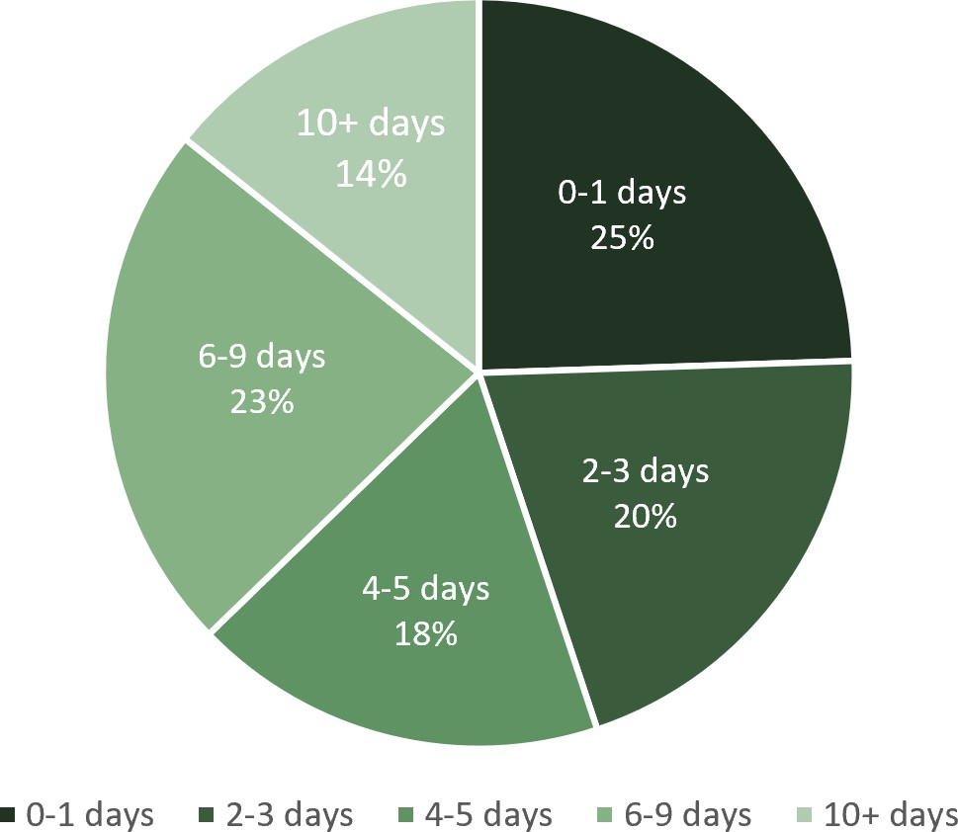
Response Times

Advice on ethics, integrity, and interests Functions

Number of Requests
This financial year, the Integrity Commissioner received 307 formal requests for advice about ethics, integrity, and post-separation matters.
The Integrity Commissioner provided 196 formal advices in response.
Of the advices provided, 82 were provided to members of the Legislative Assembly, of which:
- 61 were provided pursuant to written requests under chapter 3, part 2 of the
Integrity Act 2009, and
- 21 advices arose from meetings held with members of the Legislative Assembly.

Of the remaining 111 of the 307 advice requests received and which were not met with formal advice from the Integrity Commissioner:
- 34 requests were dealt with by preliminary oral or written opinion only
- 68 requests were referred to the most appropriate agency, and
- 9 requests were withdrawn.
As shown below, greater expectations from the public, a greater commitment to ethics and integrity by those responsible to the public, and heightened ethical awareness more generally have led to a sustained level of demand for services provided by the commission over the three years of the current Integrity Commissioner tenure.

Number of requests – All years of the integrity commissioner
Number of Requests

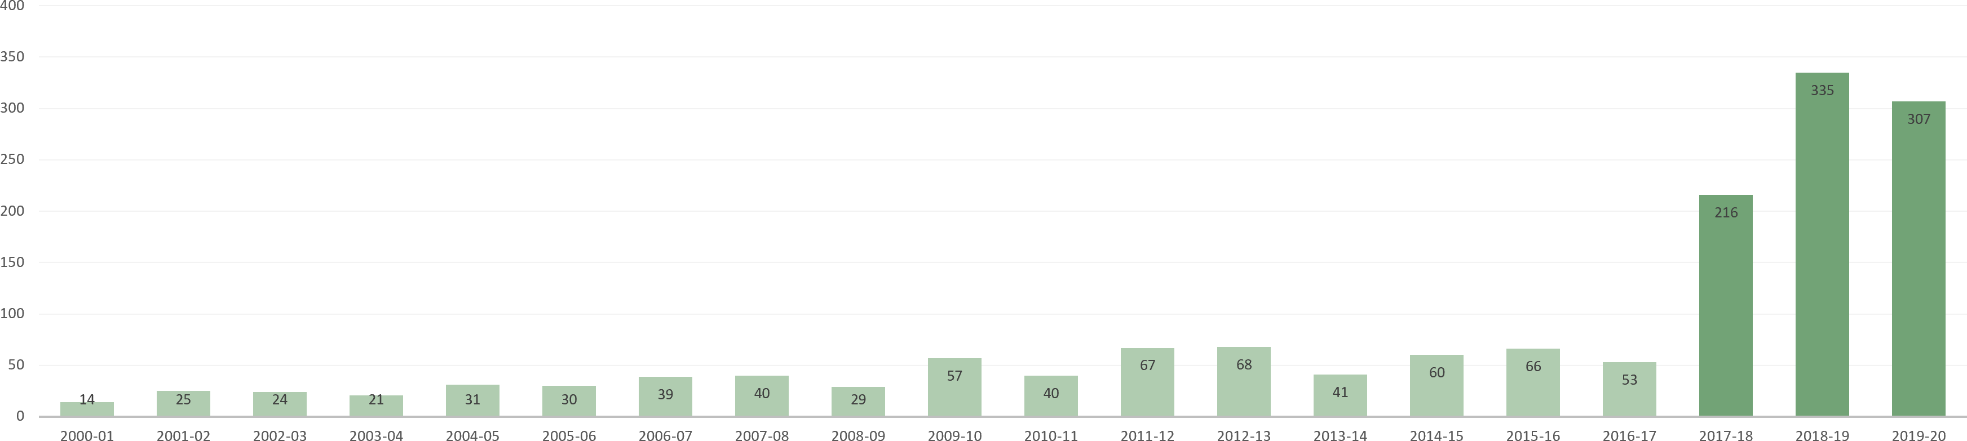
Reporting Years

LOBBYISTS FUNCTION
Section 7(1)(c) of the Integrity Act 2009 states that it is a function of the Integrity Commissioner to keep the lobbyists register and have responsibility for the registration of lobbyists.
Since 2010, the Integrity Commissioner has been responsible for administering the regulation of lobbying activities under the Integrity Act 2009. This involves the maintenance of the lobbyists register.

Entities
Queensland Register of Lobbyists

Registered De-registered

113
4

The regulatory system is based on the requirement, under section 71 of the Integrity Act 2009, that ‘government representatives’ must not knowingly permit an entity that is not a registered lobbyist to carry out lobbying activity for a third party client with the government representative.
The Integrity Commissioner has no investigative powers under the Integrity Act 2009. Where appropriate, the Integrity Commissioner is able to refer matters of concern to the relevant agency, such as the Queensland Police Service or the Crime and Corruption Commission, for assessment and possible investigation and prosecution.

Register of lobbyists contact
The Integrity Commissioner is responsible for maintaining the Queensland register of lobbyists and the obligation on lobbyists to file details of their lobbying contacts in accordance with the Lobbyists Code of Conduct.
As part of ongoing checks, and to assist in the Integrity Commissioner’s discharge of her functions and powers under the Integrity Act 2009, in November 2019 the Integrity Commissioner wrote to all departments and councils requesting confirmation that all lobbying contacts with officers within their or their related units of administration were properly recorded by lobbyists on the Register.
All bodies provided responses as to compliance, except for one council which declined on the grounds that it does not keep centralised lobbying records. However, the council is now seeking to rectify the matter. The Register is published on our website at:
https://lobbyists.integrity.qld.gov.au/ContactLog.aspx.

Listed Persons

Code of Conduct

300
8
Lobbyists are required to comply with a Lobbyists Code of Conduct which imposes a set of ethical obligations and responsibilities on professional lobbyists seeking to influence government policy and decision making, while representing the interests of another person or body for a fee or other reward.
Ethical lobbying is widely regarded to be a legitimate activity as part of the contest of ideas in the democratic process. Lobbyists can assist individuals and organisations to communicate their views to government and opposition representatives on matters of public interest. However, there are also inherent integrity risks with the commercialised aspects of lobbying. Lobbyists perceived to have personal influence over decision- makers, often because of past public sector roles or pre-existing associations and ties, tend to be highly sought after. Typically, lobbyists are also former politicians and ministerial or party staff. The Lobbyists Code of Conduct (Code) includes the following obligation:
‘Lobbyists shall keep strictly separate from their duties and activities as
lobbyists any personal activity or involvement on behalf of a political party.’

LOBBYISTS FUNCTION

Code of Conduct Cont’d
The Code does not prevent ongoing personal activity or involvement on behalf of a political party. An example of a breach of the Code would likely include the lobbyist’s political support for a government representative, being expressed as dependant on the outcome of their lobbying activity. This document is available online at:
www.integrity.qld.gov.au/lobbyists/obligations-code-of-conduct.aspx.

Resources for lobbyists
To meet demand for advice and information about lobbying, the office of the Integrity Commissioner developed and published a ‘Common Questions and Answers’ factsheet (similar to a Frequently Asked Questions) on our website at:
https://www.integrity.qld.gov.au/lobbyists/lobbying-questions-answers.aspx.

However, ‘lobbying activity’ under the Integrity Act 2009 may not be clearly distinct from other conduct, and depends on the individual facts. To assist in a consideration of the issues, the office of the Integrity Commissioner began in early 2020 to publish a series of questions and answers, based on common questions received in relation to lobbying and in working with lobbyists. While not intended to give a definitive legal position, they reflect the office of the Integrity Commissioner’s current understanding and interpretations.
The office of the Integrity Commissioner has also developed a framework that is applied, taking into account the Integrity Act 2009, when assessing whether the conduct of a person or entity might warrant removal from the Register or refusal to register an entity or list a person.

Number of Requests for Advice about Lobbying
When Dr Stepanov commenced as Integrity Commissioner, requests for advice or guidance on lobbying issues were relatively few. However, this financial year, the Integrity Commissioner received 35 requests for advice and general enquiries about lobbying.
This represents a very significant increase in comparison to the 2015-2017 period, noting that, as below, similarly high numbers have occurred sporadically over the past 11 years.

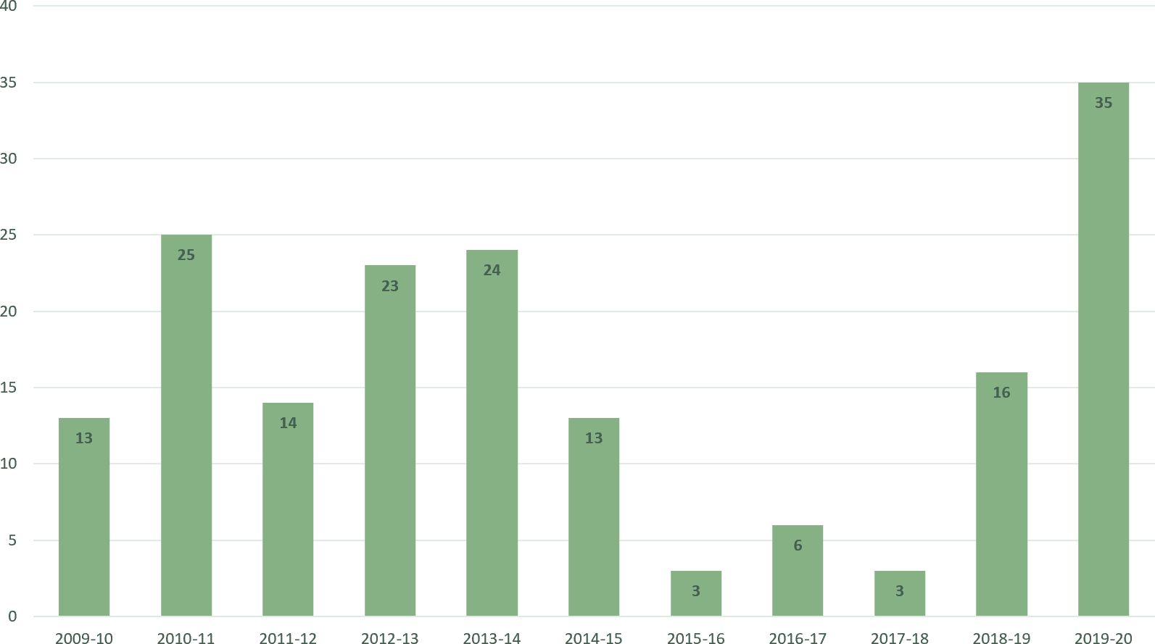
LOBBYING REQUESTS FINANCIAL YEARS JULY 2009 – JUNE 2020

LOBBYISTS FUNCTION

Post-Separation Restraints
Historically, there are public concerns that former senior public officials or public servants might seek to personally benefit from the networks and information gained through public service.
Section 70 of the Integrity Act 2009 prohibits a ‘former senior government representative’, which includes a former ministerial staff member, from carrying out ‘related lobbying activity’ for a ‘third party client’ within two years of their separation from Queensland public sector employment.
‘Related lobbying activity’ refers to matters in which the ‘former senior government representative’ has had ‘official dealings’ in the two years prior to separation.
While not defined in the Integrity Act 2009, the Integrity Commissioner considers that ‘official dealings’ would include even formal attendance at briefings or receiving confidential analysis on a particular matter.
There is also an obligation under the Integrity Act 2009 (section 71(2)) on current ministerial and government employees to not meet with any ‘former senior government representative’ in circumstances that would give rise to a breach of the post-separation restraints, including with respect to lobbying.
The lobbying provisions of the Integrity Act 2009 were extensively reviewed in the 2015 ‘Strategic Review of the Functions of the Integrity Commissioner’ and the ‘Inquiry into the Report on the Strategic Review of the functions of the Integrity Commissioner’ by the then Parliament Finance and Administration Committee in December 2015.
The Integrity Commissioner acknowledges the heightened concerns about lobbying and post-separation matters and therefore supports any further overall review of these provisions of the Integrity Act 2009 as part of the Strategic Review of the Integrity Commissioner’s functions next due in 2021.

Number of requests about post-separation restraints
Included in the overall number of advice requests are 12 written advices provided in response to requests from current or former public officials, ministerial staff, or public servants, in relation to their post-separation obligations.

PUBLIC AWARENESS FUNCTION
The Integrity Commissioner is statutorily obliged, under section 7(1)(d) of the Integrity Act 2009 to raise public awareness of ethics or integrity issues by contributing to public discussion about the Integrity Commissioner’s functions, and by raising public awareness of ethics and integrity issues more generally.
Ethics and integrity issues are entwined in a broad range of matters concerning government structure, practices and policies, and contributions to enhanced awareness is important.

Delivering the message across Queensland
Throughout 2019-2020, the Integrity Commissioner had 103 interactions, delivering 32 information sessions to bodies such as statutory boards, local government and other public sector entities; 19 preliminary education events (seminars, conferences etc.), and participated in 52 office of the Queensland Integrity Commissioner facilitated committee meetings, other meetings, and events.
In discharging this area of responsibility, the Integrity Commissioner collaborated on a number of shared initiatives with other members of the Integrity Committee including:
- the Public Safety and Associated Agencies International Women’s Day event to support and champion women within the Queensland Police Service, Queensland Corrective Services, Queensland Fire and Emergency Services, Inspector-General Emergency Management, Queensland Integrity Commissioner and Crime and Corruption Commission.
- as co-patron of the Public Safety and Integrity Agencies Women’s Network (‘Leading Women’), including by contributing as co-hosts alongside the Crime and Corruption Commission and the Inspector-General Emergency Management to the ‘Leading Women’s Podcast’ event.
- the ‘Making 2020 local government elections #fairforall’ campaign together with the Crime and Corruption Commission, Electoral Commission of Queensland and the Office of the Independent Assessor.
- the ‘Local Government: Roles and Functions of Queensland Integrity Agencies Live Webcast’ together with the Crime and Corruption Commission and the Office of the Independent Assessor.

Public awareness function

attendance
The Integrity Commissioner travelled to Townsville to present to the North Queensland Regional Organisation of Councils in July 2019.
As well, whilst the Integrity Commissioner was acting as the Health Ombudsman, the Acting Integrity Commissioner, Mr Mark Glen, travelled to Cairns in October 2019 to attend the Local Government Association of Queensland Annual Conference.
As part of her commitment to ongoing professional development, the Integrity Commissioner attended a number of conferences and seminars, including in person at the Governance Institute of Australia National Conference in Sydney and the Australia Public Sector Anti-Corruption Conference in Melbourne; as well as taking part in a number of online seminars and events.

Resources & development
To meet the need for training and education within the context of a pandemic, the office of the Integrity Commissioner sought to gain some new skills and have added developing podcasts to their broadening repertoire.
To date the Integrity Commissioner, staff, and various key collaborators have developed two podcast series:
- the Leading Women’s series, and
- the Integrity in Health series.
Interest issues are becoming increasingly more complex, more varied, and less visible. Therefore, maintaining recency of training and education, are critical to ensure modern and ethical professional practice standards are maintained.
The office of the Integrity Commissioner has particular expertise in delivering education and training, and developing resources, including Conflict of Interest Meeting Aids, for Queensland Government multi-member decision-making boards and bodies.

Leading women’s event
Leading Women is an inter-agency women’s network including partner agencies: Queensland Police Service; Queensland Fire and Emergency Services; Public Safety Business Agency; the Crime and Corruption Commission, and Queensland Corrective Services.
On 15 May 2020, the event was delivered in a different format given the unprecedented times we are facing due to the current health crisis.
We launched a series of podcast interviews with representatives from our partner agencies, who share their views on the topic of “Inclusion, not just diversity”, including:
- Dr Kevin Cocks AM, former Queensland Anti-Discrimination Commissioner
- Katarina Carroll APM, Queensland Police Service Commissioner
- Peter Martin APM, Queensland Corrective Services Commissioner
- Greg Leach, Queensland Fire and Emergency Services Commissioner
- Alistair Dawson APM, Inspector-General Emergency Management
- Kurt Marsden, Acting Chief Operating Officer, Public Safety Business Agency
- Sarah March, Director, Governance and Reporting, Inspector-General Emergency Management
- Karen McCarthy, Senior Lawyer, Crime and Corruption Commission, and
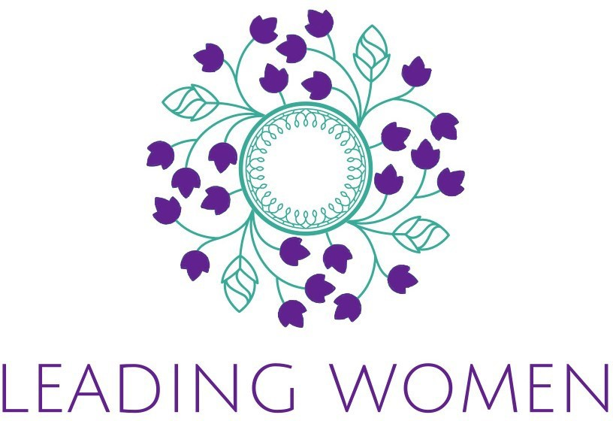
- Dr Nikola Stepanov, Queensland Integrity Commissioner.

Public awareness function

Local government joint webinar
On 20 May 2020, three of Queensland’s integrity agencies partnered to equip newly- elected and existing Local Government councillors and mayors with information to assist them in understanding the integrity agencies’ roles and functions, and the obligations these officials hold under their respective legislation.
The webinar was hosted by the leaders of three of Queensland’s integrity agencies:
- Alan MacSporran QC, Chairperson of the Crime and Corruption Commission
- Dr Nikola Stepanov, Queensland Integrity Commissioner, and
- Kathleen Florian, Queensland Independent Assessor.
The 90-minute webinar covered matters including how to manage conflicts of interest, councillors’ obligations in relation to their registers of interest, and steps to ensure that a council has a robust framework to manage and deal with corruption and misconduct. Over 190 people registered for the webinar across Queensland, including many councillors and mayors.

Integrity in health series
Each year the office of the Integrity Commissioner, together with its supporting partners, including Health Ethics and Law Queensland (HEaL), arranges an ‘Integrity in Health‘ series of events. The topic for the 2019-2020 reporting year was ‘Mandatory reporting for Health Professionals: What are the ethical and legal ramifications?’. As a result of the global pandemic, the series was provided by way of podcasts, and we were delighted to share our Integrity in Health journey with our partners:
- the Office of the Health Ombudsman
- Doctors’ Health In Queensland
- Avant, and
- HEaL (which is the Queensland chapter of the Australasian Association of Bioethics
and Health Law (AABHL)).

The podcast series considered a range of topics around the mental health of health professionals, available avenues of assistance, as well as the ongoing effects of the COVID- 19, pandemic on medical professionals.
The Integrity in Health Series Podcast is available at: https://www.integrity.qld.gov.au/
publications/podcasts/queensland-integrity-in-health/index.aspx.

Queensland integrity committee
Queensland enjoys a multi-agency integrity model. This model is anecdotally considered to be the ‘gold standard’ as responsibilities are divided.
In August 2001, the inaugural Integrity Commissioner, the Honourable Alan Demack AO (2000-2004) convened the first meeting of the Integrity Committee. Since then the Integrity Committee has met quarterly to discuss shared issues.
Members of the Integrity Committee include: the Chair of the Crime and Corruption Commission, the Auditor-General, the Queensland Ombudsman, the Information Commissioner, the Commission Chief Executive of the Public Service Commission, the Queensland Racing Integrity Commissioner, the Independent Assessor, and the Queensland Electoral Commissioner.
For 2019-2020, the Integrity Committee met on 16 July 2019, 9 October 2019, and 17 December 2019. Due to the COVID-19 crisis, a March 2020 meeting was cancelled and instead an update of activity from January to May 2020, was provided by each agency and made publicly available on 11 June 2020 (‘Integrity Committee Update: January to May 2020’).
The ‘Integrity Committee Update: January to May 2020’ and ‘Meeting Notes’ for the 16 July 2019, 9 October 2019, and 17 December 2019, Integrity Committee meetings, are available on the office of the Integrity Commissioner’s website at:
https://www.integrity.qld.gov.au/publications/integrity-committee-meeting-notes.aspx.

Operational and compliance matters

Declarations of Interests
Section 72C of the Integrity Act 2009 provides that various statutory office holders must provide a copy of their Declaration of Interests to the Integrity Commissioner.
Similarly, chief executives are required by section 101 of the Public Service Act 2008 to provide copies of their Declaration of Interests to the Integrity Commissioner.
Section 85(2) of the Integrity Act 2009 requires the Integrity Commissioner to provide details of compliance by statutory office holders and chief executives in this respect.
As at 30 June 2020, all statutory office holders and chief executives had complied with these requirements. Declarations made by Directors-General are now published on the Public Service Commission website at: www.psc.qld.gov.au.
In accordance with the Integrity Act 2009, the Integrity Commissioner has provided the Speaker with her own Declaration of Interests and amended Declarations as necessary.
Under part 2, sections 72D-F of the Integrity Act 2009, the declarations of interests, and, where relevant, related party and/or revised declarations, of statutory office holders named in Schedule 1 of the Integrity Act 2009, and other parties where prescribed under a regulation, Act, directive, or policy, are received and held by the Integrity Commissioner.
As a general position, the Integrity Commissioner receives many hundreds of declarations each year from across sectors and settings.
Further, by agreement, the Integrity Commissioner is also responsible for receiving and storing other declarations on a case by case basis. For example, each financial year the Premier and other Ministers are required to complete the Australian Accounting Standard AASB 124 Related Party Disclosures. The Integrity Commissioner receives these forms on behalf of Queensland Treasury, and makes them available for review by the Auditor- General.

Ministerial code of conduct
Under the Ministerial Code of Conduct, Ministers and Assistant Ministers are obliged to
meet with the Integrity Commissioner at least once every 12 months.
During the 2019-2020 financial year, the Integrity Commissioner had meetings with or provided advice to each Minister and Assistant Minister.
Pursuant to amendments to the Ministerial Code of Conduct made during the 2019-2020 financial year, Ministers are required to have in place a Conflict of Interest Management Plan in relation to real, perceived or potential conflicts of interest.
The Management Plan must detail the personal interest, the potential grounds of the conflict, and the proposed actions to manage the conflict. It must be provided to the Premier within a month of being sworn into office or any time there is a change in the Minister’s interests that give rise to a potential conflict. The Minister must also obtain the Integrity Commissioner’s advice on the actions proposed.
Following these amendments, the Integrity Commissioner has endorsed or proposed numerous Management Plans for submission to the Premier and holding by the Department of the Premier and Cabinet.
While Management Plans cannot deal with every conceivable conflict that might arise, they help to ensure that the most likely potential issues are considered well before any related matter comes before the Minister for decision.

Submissions and hearings
The Integrity Commissioner appeared before the Economics and Governance Committee in public briefings in fulfilment of the Committee’s statutory oversight function held on 30 March 2020. The Integrity Commissioner also appeared before the Economics and Governance Committee in relation to the Electoral and Other Legislation (Accountability, Integrity and Other Matters) Amendment Bill 2019. The Integrity Commissioner also provided the following submissions:
- Electoral and Other Legislation (Accountability, Integrity and Other Matters) Amendment Bill 2019 on 9 January 2020, plus further submission on 31 January 2020
- Criminal Code and Other Legislation (Ministerial Accountability) Amendment Bill 2019
on 10 February 2020, and
- Overview of the Queensland Integrity Commissioner—Half Year Annual Update on 23 March 2020.

Operation and compliance matters

Staffing and Resources
Four permanent fulltime equivalent (FTE) positions exist to support the Integrity Commissioner perform her functions. At present, of the four permanent positions, one position is vacant, and one is filled on a temporary basis.
Following the nomination of mayors and councillors in 2018, a further 2.8 FTE were provided to support the Commissioner on a temporary basis for the financial year 2018- 2019.
During the financial year of this report, one temporary FTE was provided to one year, in addition to the four permanent FTE.
The Commissioner took several periods of leave during the financial year:
- Four weeks of annual leave
- Four weeks unpaid leave from the role of Commissioner in order to backfill leave arrangements for the Queensland Health Ombudsman, and
- One week fulltime deployment as part of the Government’s COVID-19 response.
During the Commissioner's absence, the role was filled by the Acting Integrity Commissioners.
Much of the work of the Commissioner involves providing advice on complex matters where time is critical. The sustained workload has meant that the greatest challenge to the commission continues to be responding to demand without any negative impacts on advice quality, comprehensiveness, service, and timeliness.
Years of previous advices are now progressively being catalogued to aid consistency and increase efficiencies. Precedent systems and style guides have been implemented to further increase efficiencies and the quality of advices.
Monitoring systems have also been enhanced to ensure that requests are attended to in a timely manner.

Other Compliance Matters
A copy of the Records Retention and Disposal Schedule (QDAN 629 v.3) developed for the Queensland Integrity Commissioner, and approved by the Queensland State Archivist on
22 November 2013, is available on the Queensland State Archives website at:
www.archives.qld.gov.au.
No public interest disclosure applications under the Public Interest Disclosure Act 2010 were received by the Integrity Commissioner. No applications were received in relation to the advice functions of the Integrity Act 2009 and no information can be provided about the Integrity Commissioner’s activities under chapter 3 of the Integrity Act 2009.
This Annual Report and previous reports from the Integrity Commissioner are available online at: www.integrity.qld.gov.au/publications/annual-reports.aspx.

Financial statement

Queensland Integrity Commissioner Statement of Comprehensive Income Year ended 30 June 2020

2020 2019 2020 Note
Original Budget
Actual Actual Budget Variance s Budget

OPERATING RESULT  Income from Continuing Operat ions | $'000 | $'000 | $'000 | $'000 | Variance
Appropriation revenue | 1,292 | 1,309 | 1,202 | 90
Grants and other contribut ions
Total Income from Continuing Opera tions | 1,292 | 1,309 | 1,202 | 90
Expenses from Continuing Operations
Employee expenses | 840 | 1,009 | 873 | (33) | 2
Supplies and services | 340 | 295 | 327 | 13 | 3
Grants and subsidies |  | 5
Depreciation and amo rtisation |  |  | 2 | (1)
Total Expenses from Continuing Operat ions | 1,181 | 1,309 | 1,202 | (21)
Operating Resu lt for the Year | 111 |  |  | 111 | 4
OTHER COMPREHENSIVE INCOME
TOTAL COMPREHENSIVE INCOME | 111 |  |  | 111
The accompanying notes form part of these statemenst.

Explanation of major budget variances
- An increase in Approp riation revenue primarily due to meet additional temporary resourcing requirements.
- A decrease in Employee expenses primarily due to vacancies held during the financial year.
- An increase in supplies and services primarily due to higher than anticipated legal fees.
- Surplus of $0.111M has been returned to the Consolidated fund.

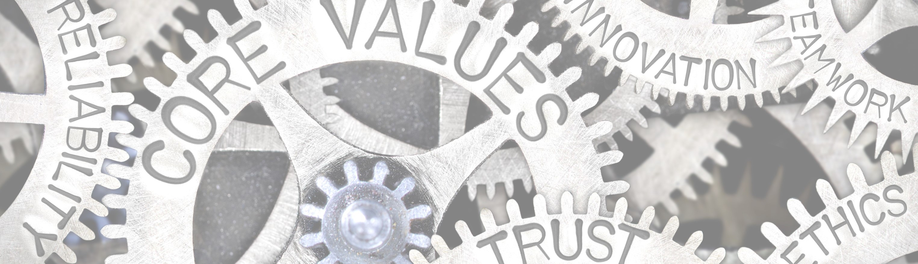

About this Report
The Annual Report provides information about the Integrity Commissioner’s financial and non-financial
performance for 2019–2020. It has been prepared in accordance with the Financial Accountability Act 2009 and the Financial and Performance Management Standard 2009.
The Annual Report has been prepared for the Speaker and
the Economics and Governance Committee for tabling in
the Legislative Assembly.
The Queensland Government is committed to providing accessible services to Queenslanders from all cultural and linguistically diverse backgrounds. If you have difficulty understanding the Annual Report, you can contact us on 07 3003 2888 and we will arrange an interpreter to
effectively interpret it.
Copies of this publication can be obtained from
www.integrity.qld.gov.au or by contacting 07 3003 2888.

Licence

This Annual Report is licensed by the State of Queensland (Queensland Integrity Commissioner) under a Creative Commons Attribution 4.0 International License.
To view a copy of this licence, visit:
http://creativecommons.org/licenses/by/4.0/

Attribution
©The State of Queensland (Integrity Commissioner) 2020 The Queensland Government supports and encourages
the dissemination and exchange of information. However, copyright protects this document.
The State of Queensland has no objection to this material being reproduced, made available online or electronically but only if it is recognised as the owner of the copyright and this material remains unaltered.
Our office location and contact details are:
Level 13, 53 Albert Street
Brisbane QLD 4000
T: 07 3003 2888
E: integrity.commissioner@integrity.qld.gov.au
W: www.integrity.qld.gov.au
Copyright enquiries about this publication should be directed to the office of the Queensland Integrity Commissioner by email to:
integrity.commissioner@integrity.qld.gov.au or in writing to Level 13, 53 Albert Street, Brisbane, Qld, 4000.

